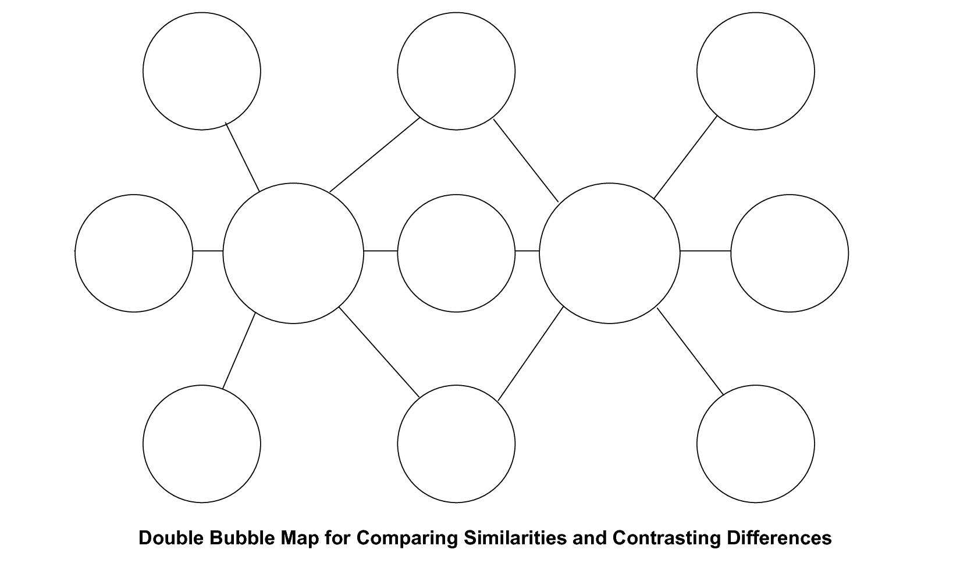
Questions Relating to Double Bubble Map
1. Describe Kit's feelings about Barbados. How do you know that she feels the way she does?

2. Describe Kit's first impression of Connecticut. How does Kit feel about arriving in America?

Often authors choose two different places in their novels to highlight differences in society and/or characters. Based on what you have read about Kit and her first impressions of America, respond to the following question prompts in a well-written paragraph.
3. Compare and contrast Barbados and Connecticut. Using examples from the story, in which of the two places does Kit seem to fit in better and why?

